[https://qtumproject.github.io/qtumjs-doc/#introduction](https://qtumproject.github.io/qtumjs-doc/" \l "introduction)

<https://blog.qtum.org/developers-guide-to-the-qtum-github-c7c1b4e0a706>

<https://steemit.com/qtum/@cryptominder/qtum-blockchain-development-environment-setup> - development

<https://steemit.com/qtum/@cryptominder/quantum-qtum-blockchain-developer-tutorial-hello-world> - development

<https://www.crypto-news-flash.com/what-is-qtum-the-blockchain-for-business-applications/>

link to QTUM documentation - <https://docs.qtum.site/en/Launch-Qtum-with-Docker.html>

Dapp on QTUM - <https://freesoft.dev/program/163513722>

**Creating a docker container for QTUM**

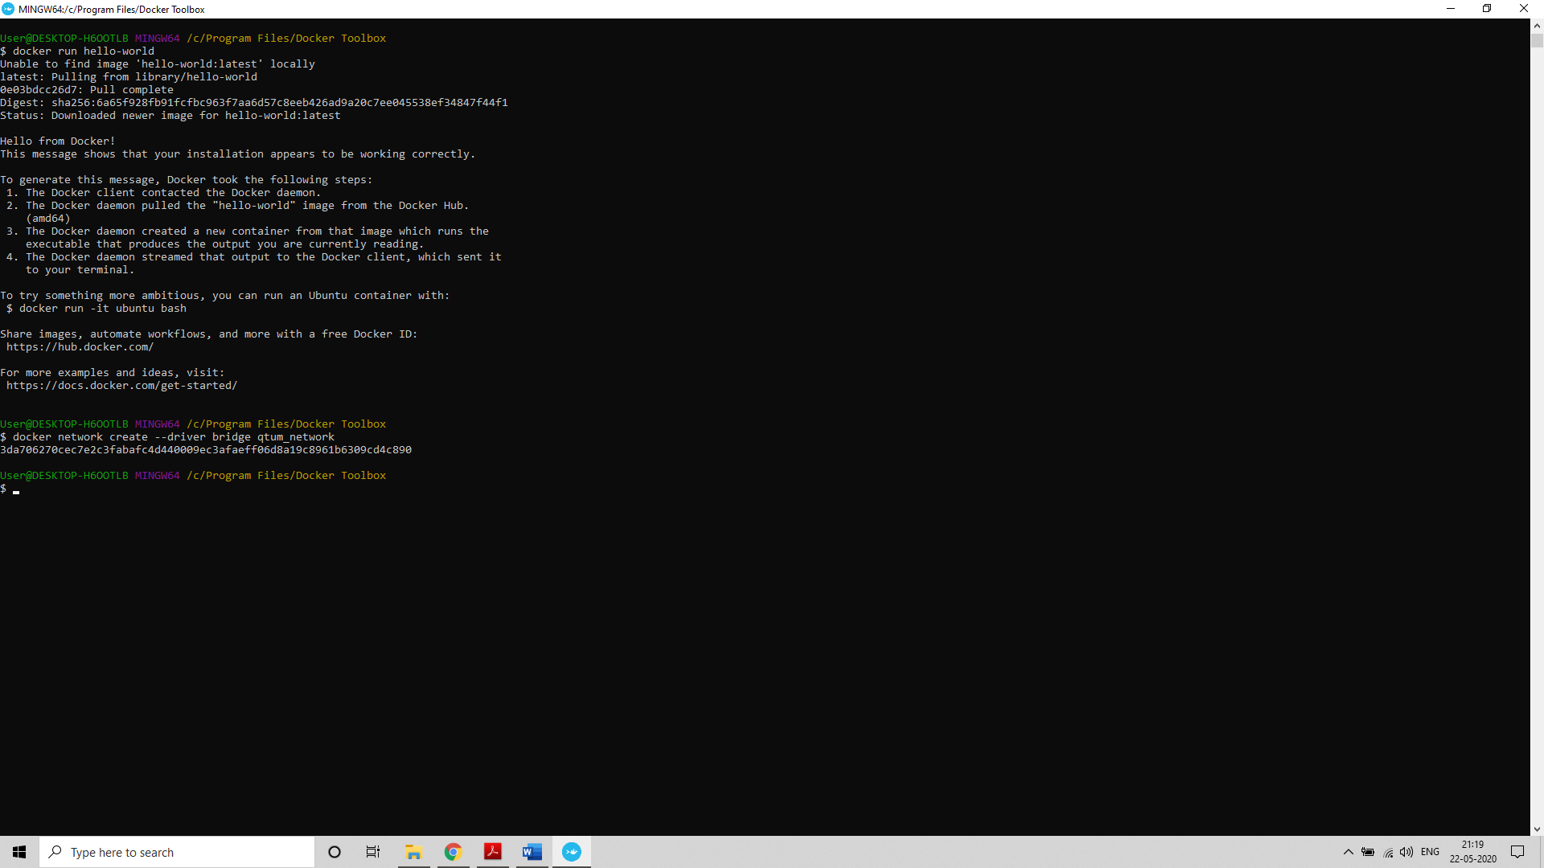

Network id - 3da706270cec7e2c3fabafc4d440009ec3afaeff06d8a19c8961b6309cd4c890

Docker network ls

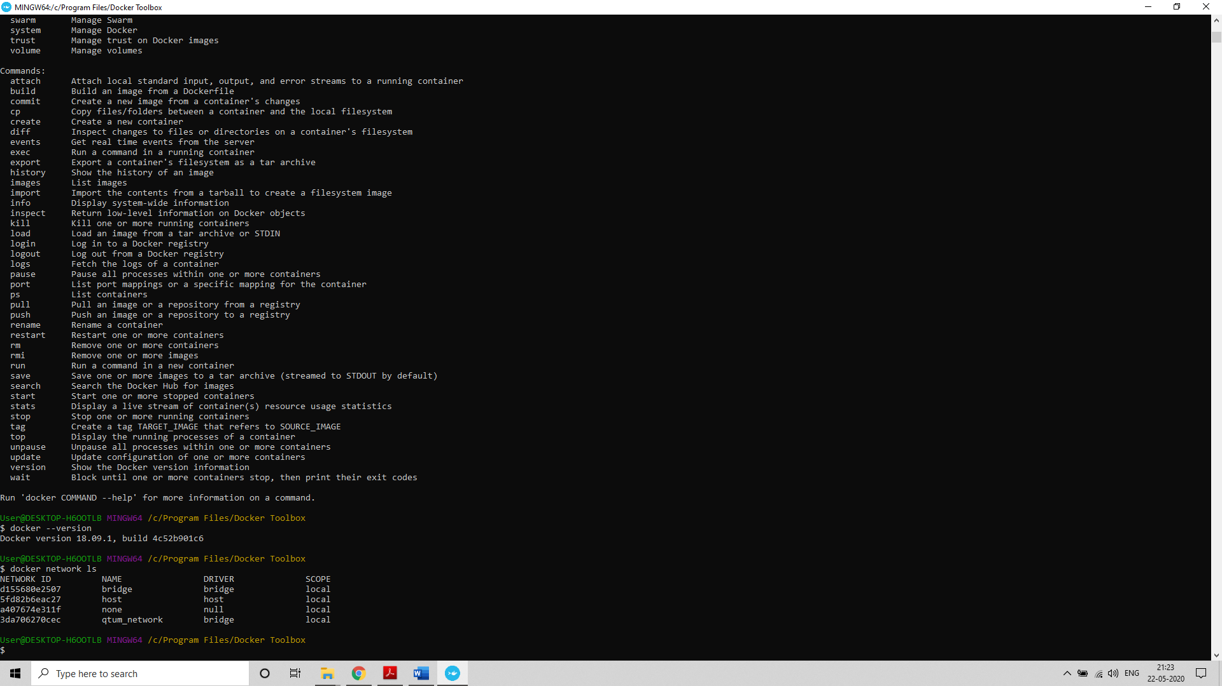

docker pull cryptominder/qtum

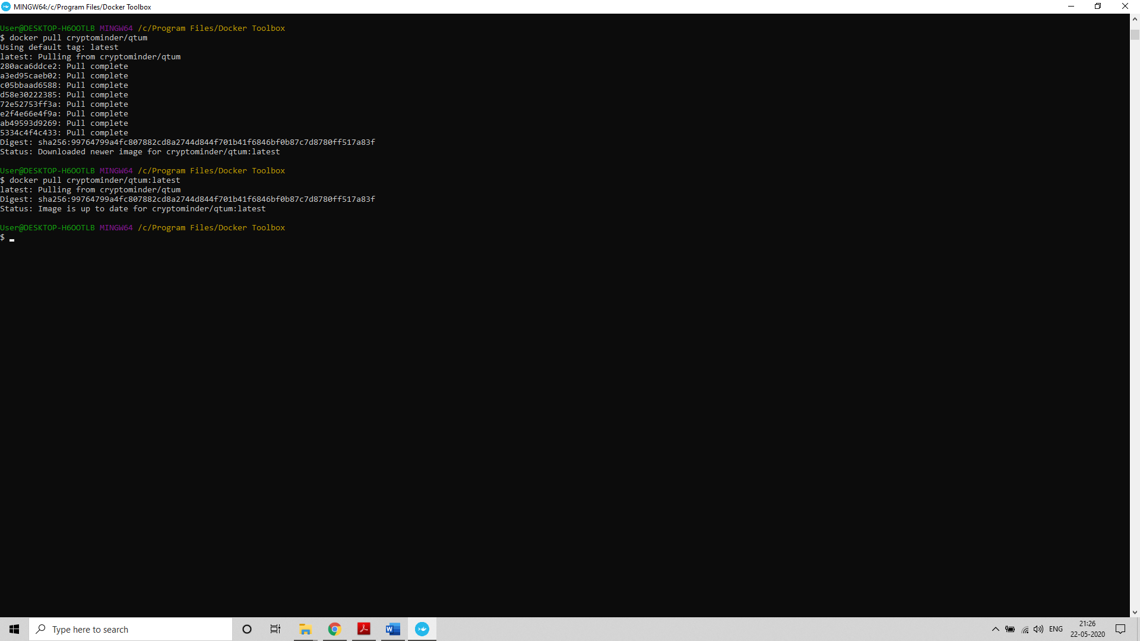

Docker images

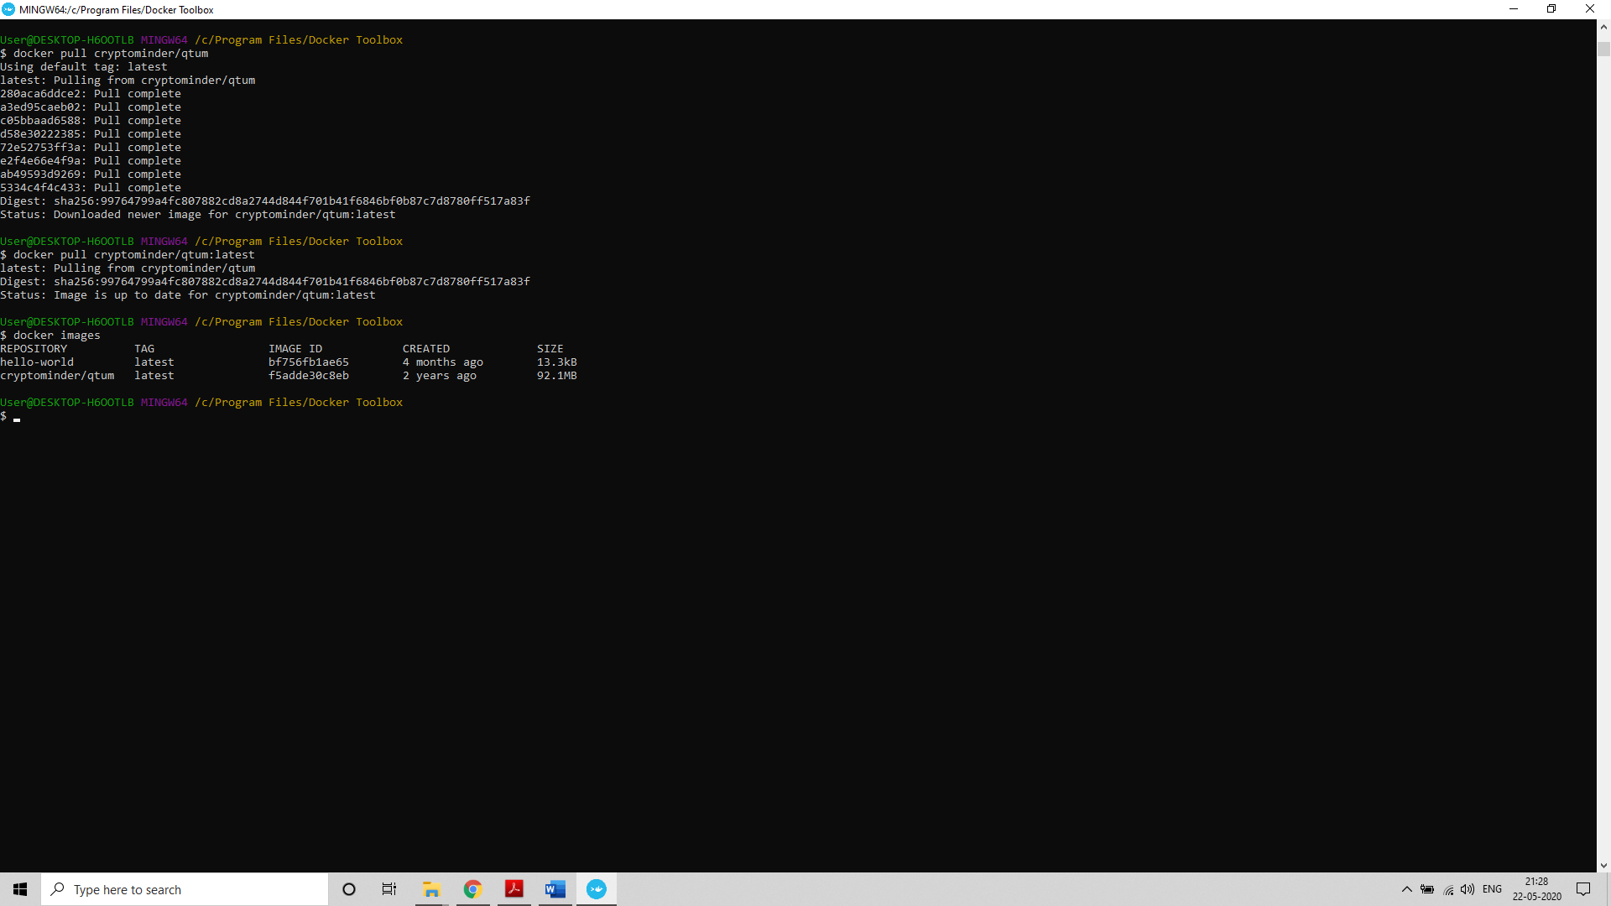

### Qtum Daemon Datadir as a Docker Volume

The cryptominder/qtum Docker image has a volume exposed at /data. We'll use a local directory (one for each node) to contain the Qtum **[datadir](https://en.bitcoin.it/wiki/Data_directory" \o "This link will take you away from steemit.com)** (e.g. where the blockchain data, the wallet file, the debug log, etc. is stored). This will allow you to stop and restart the Docker container without losing any data.

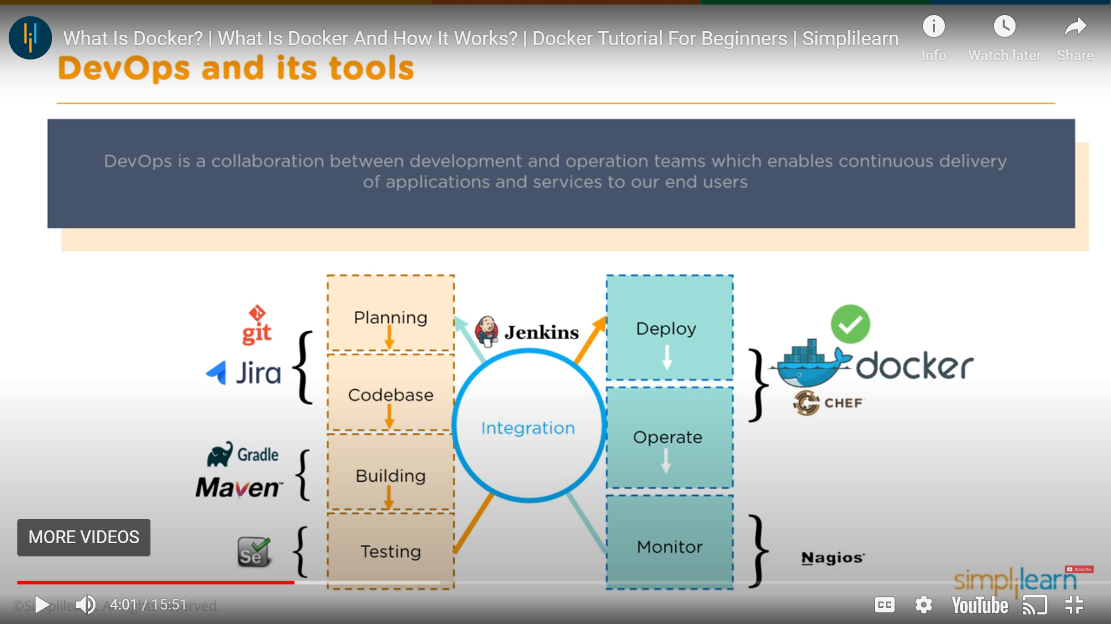

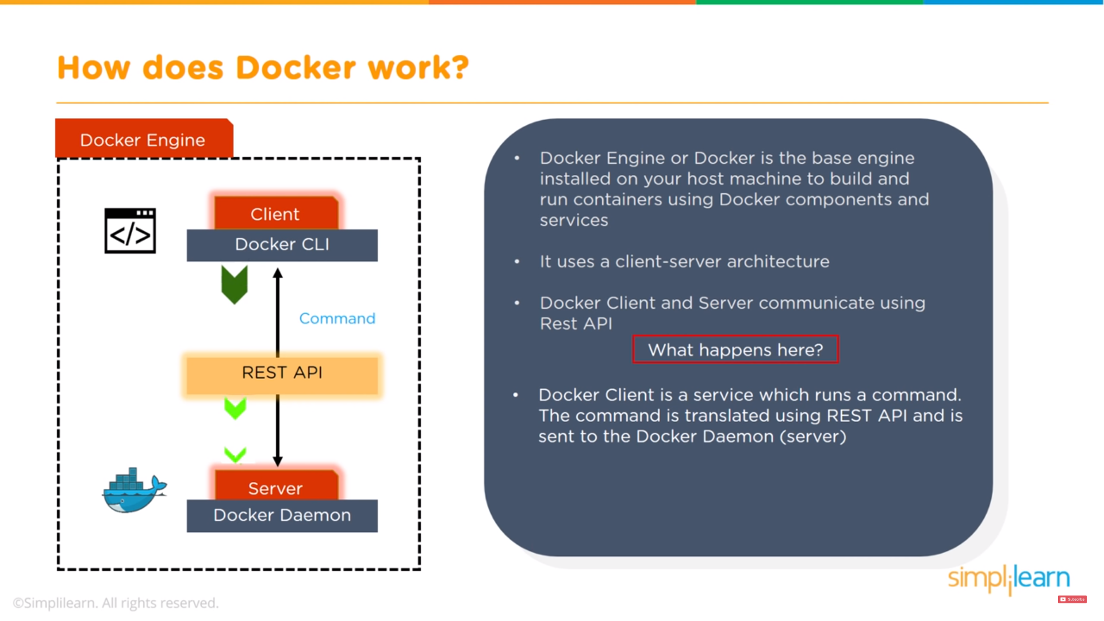

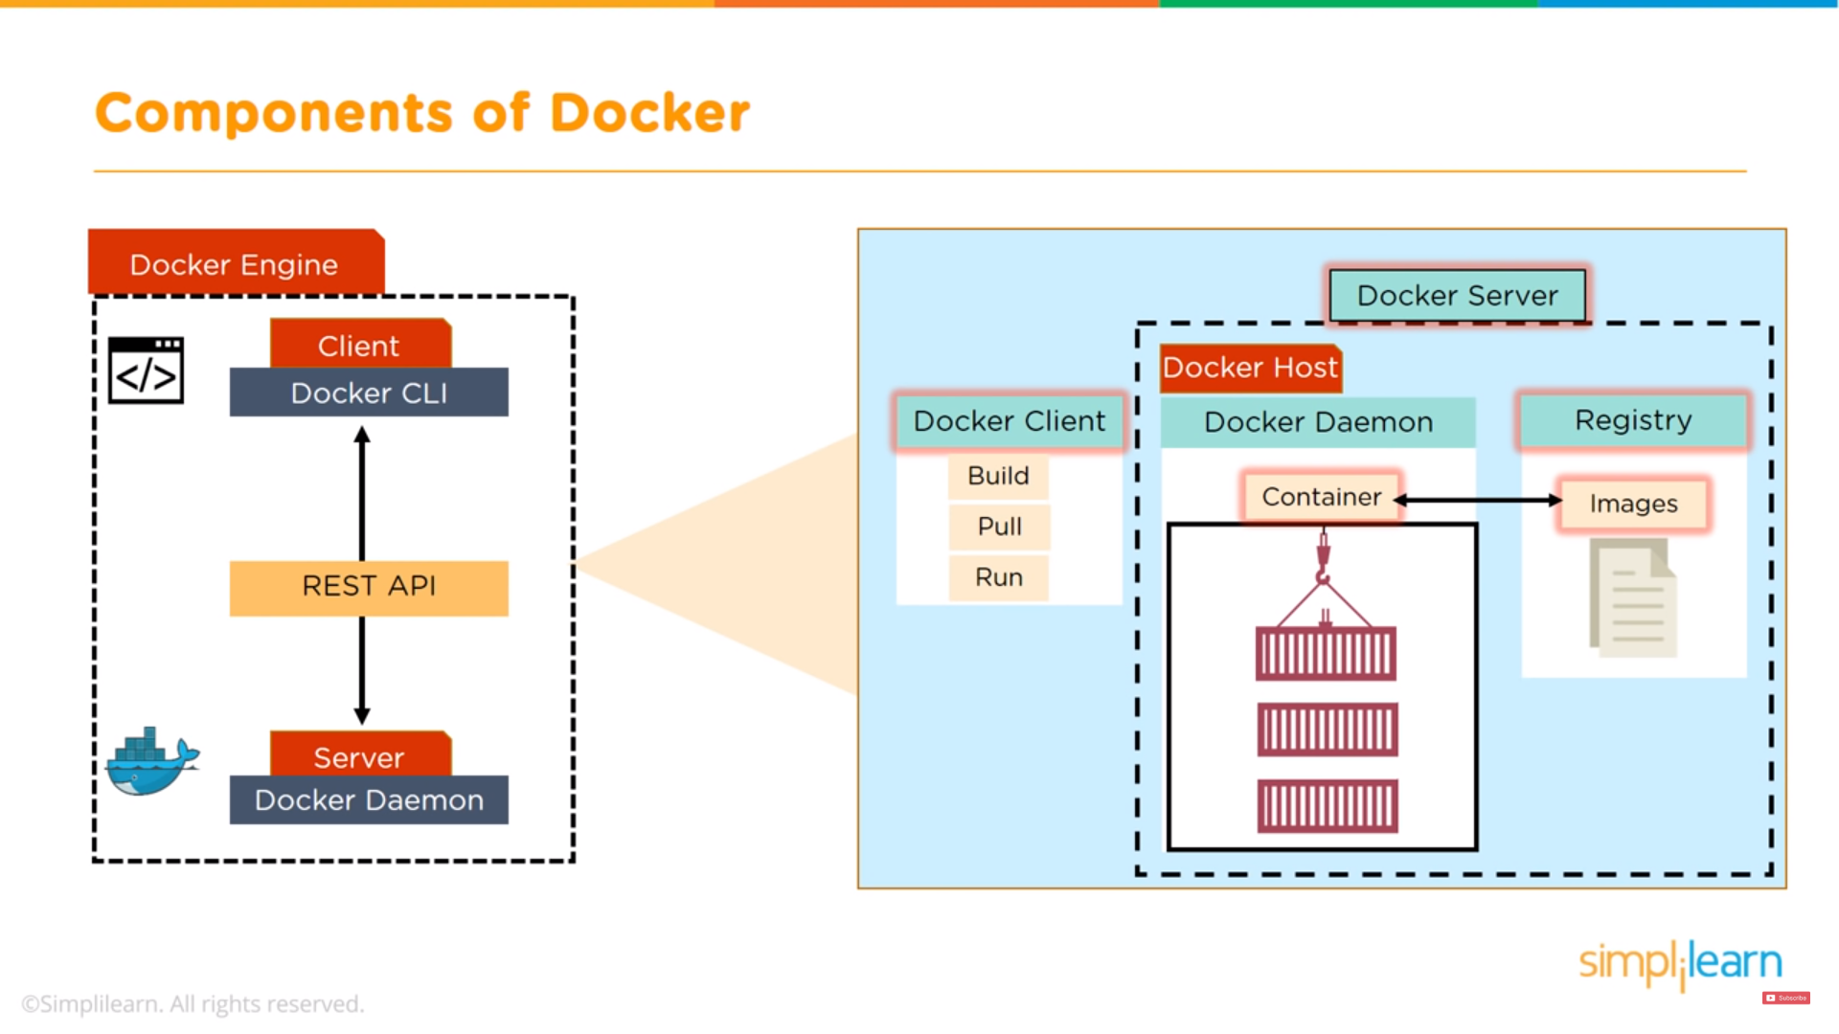

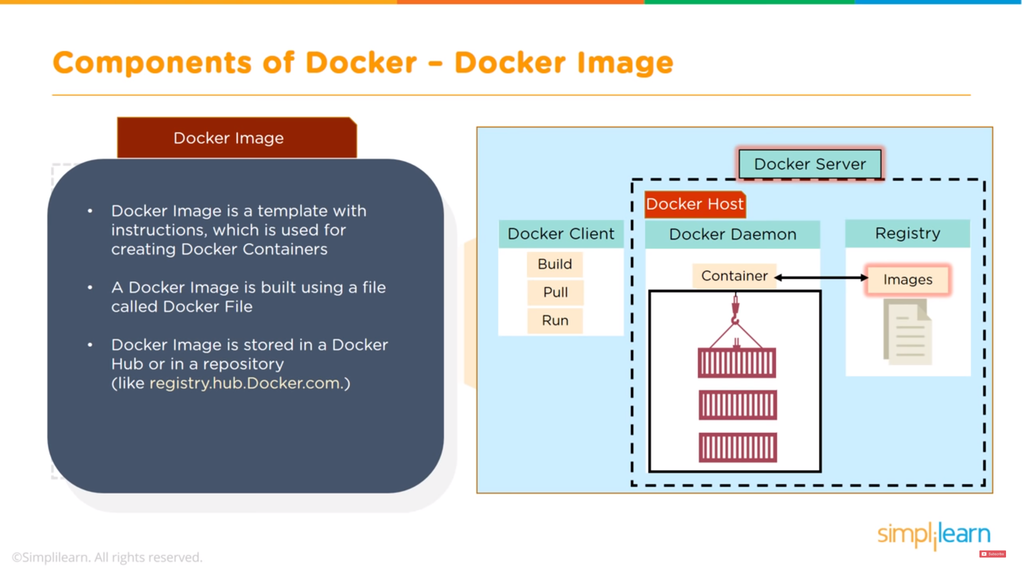

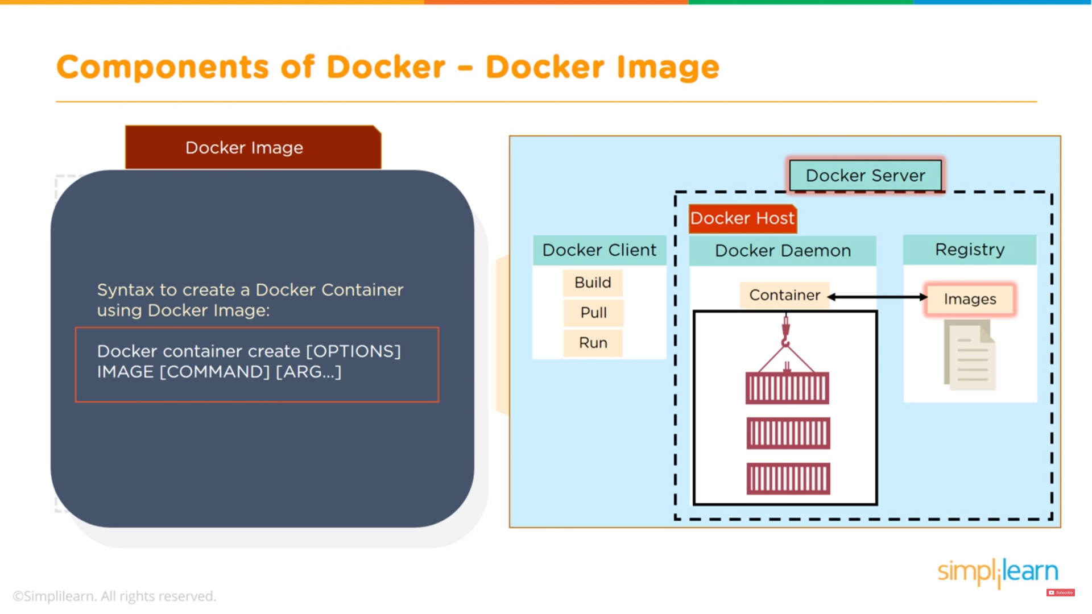

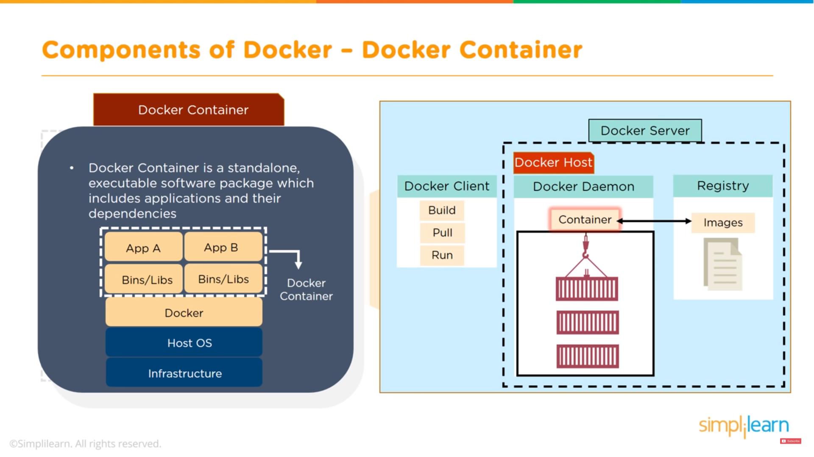

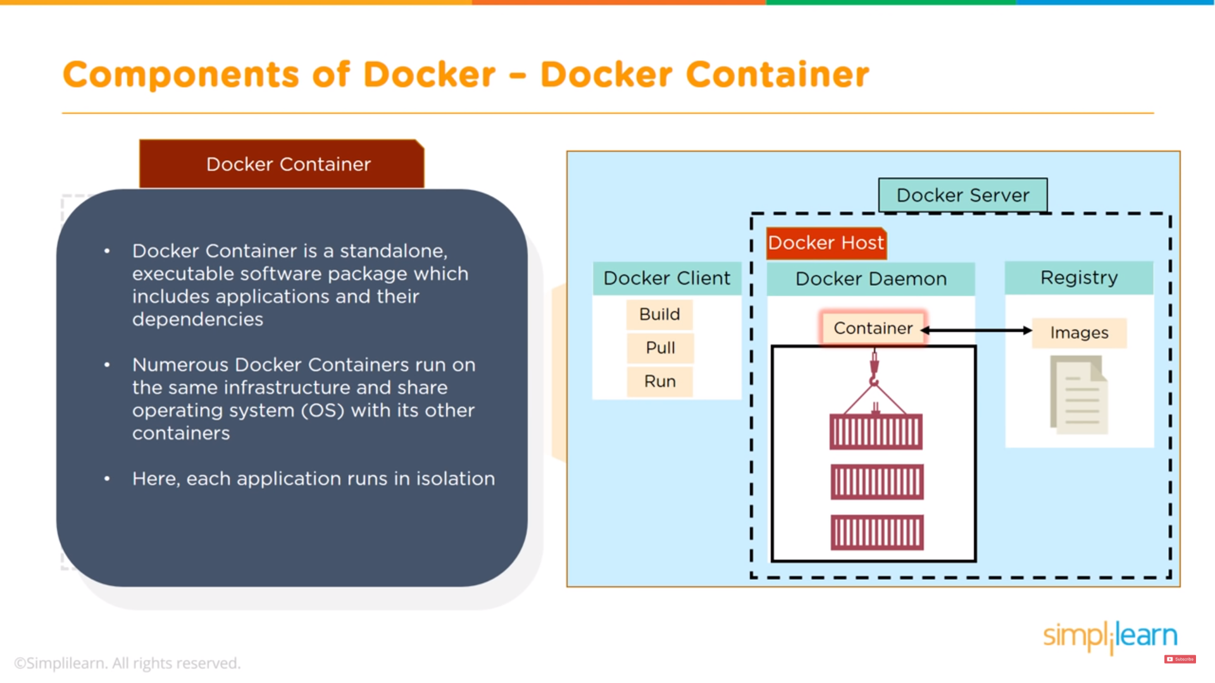

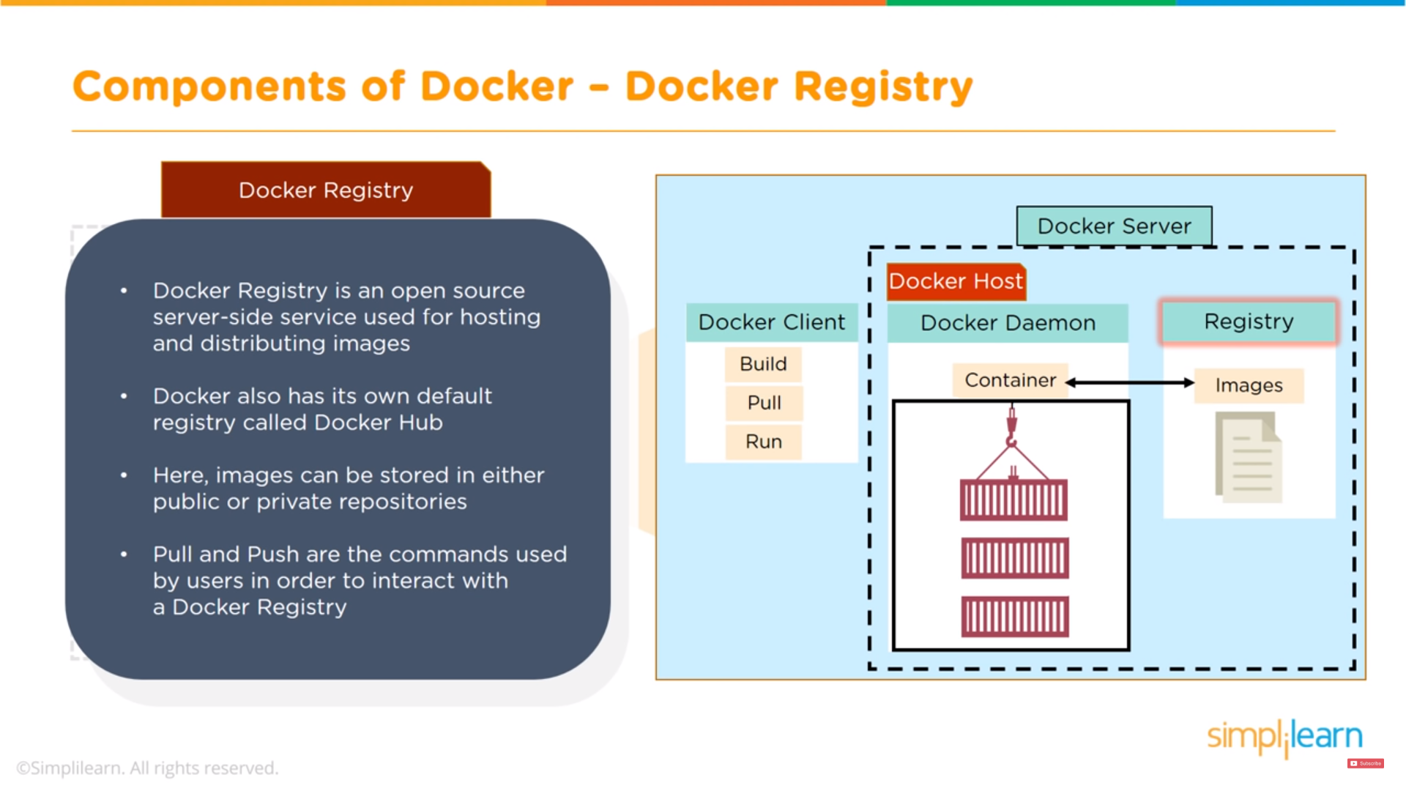

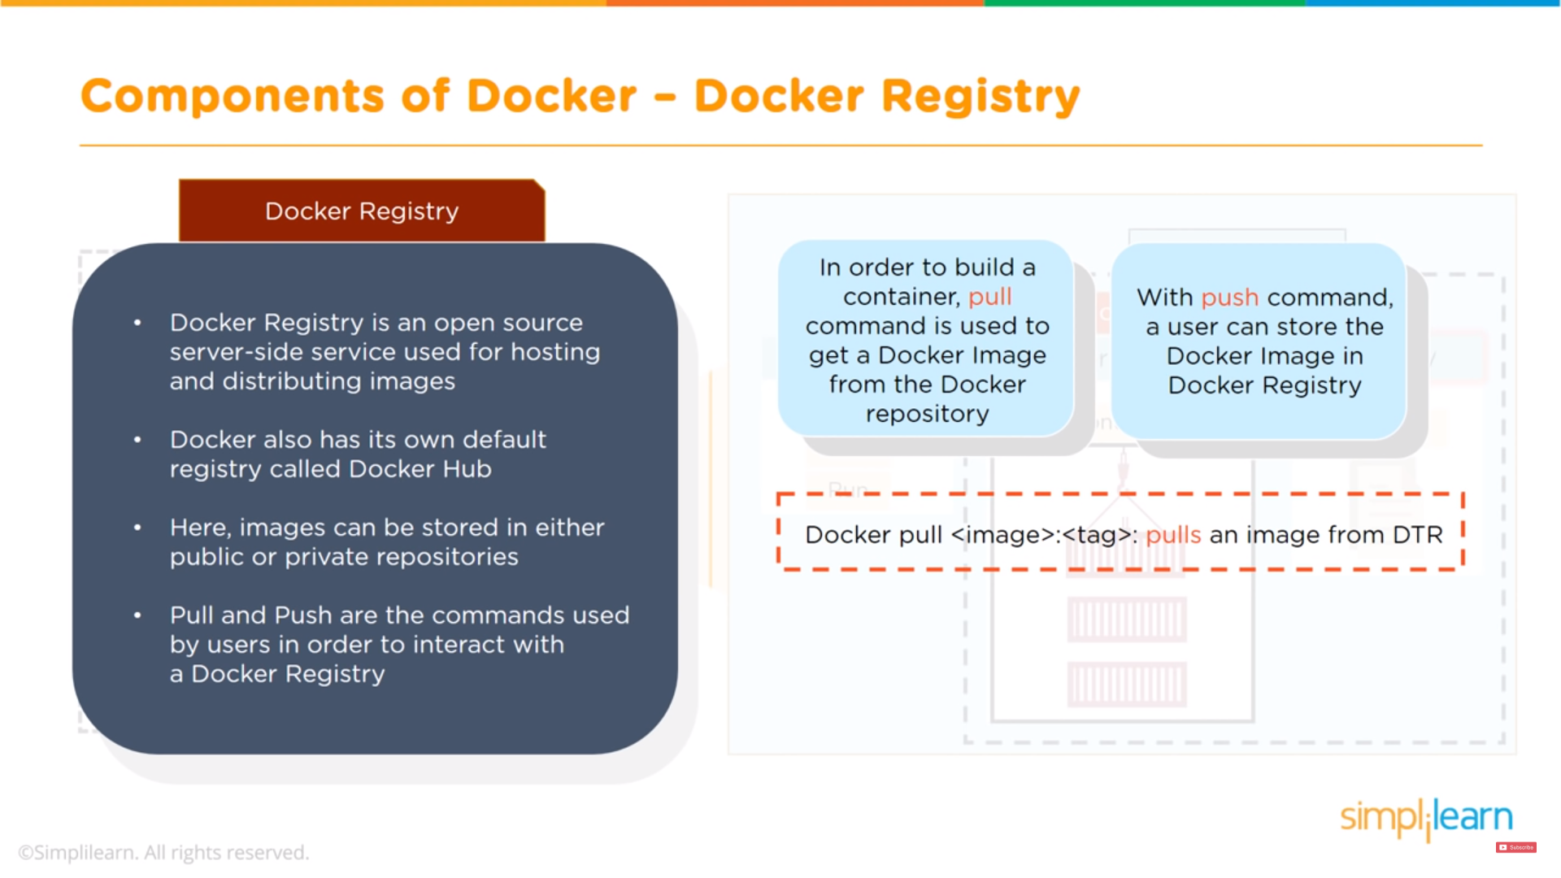

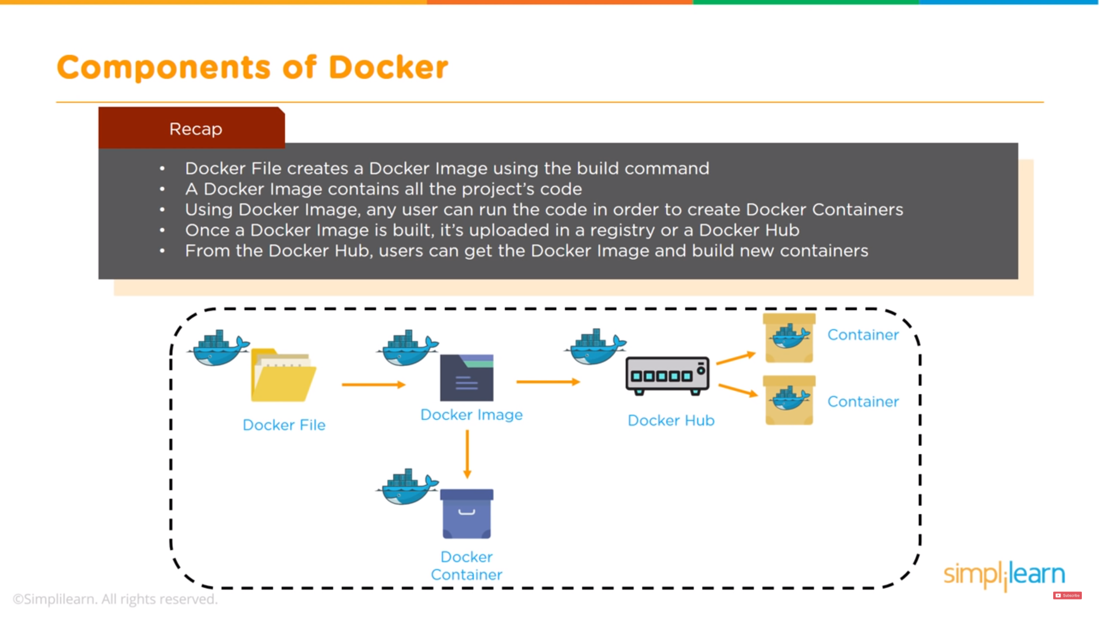

**Ran node1**

docker run -d --rm --name qtumd_node1 --network=qtum_network -v //c/QTUM/Node1/node1_qtumd.conf:/home/qtum/qtum.conf:ro -v //c/QTUM/Node1/node1_data:/data cryptominder/qtum:latest qtumd

ID: c1c4d12cd172887b251f0c3b4c5bbb42ca64875062da6ee96055f4a528e19bf3

Docker exec -it <container ID>

Cd data

docker ps

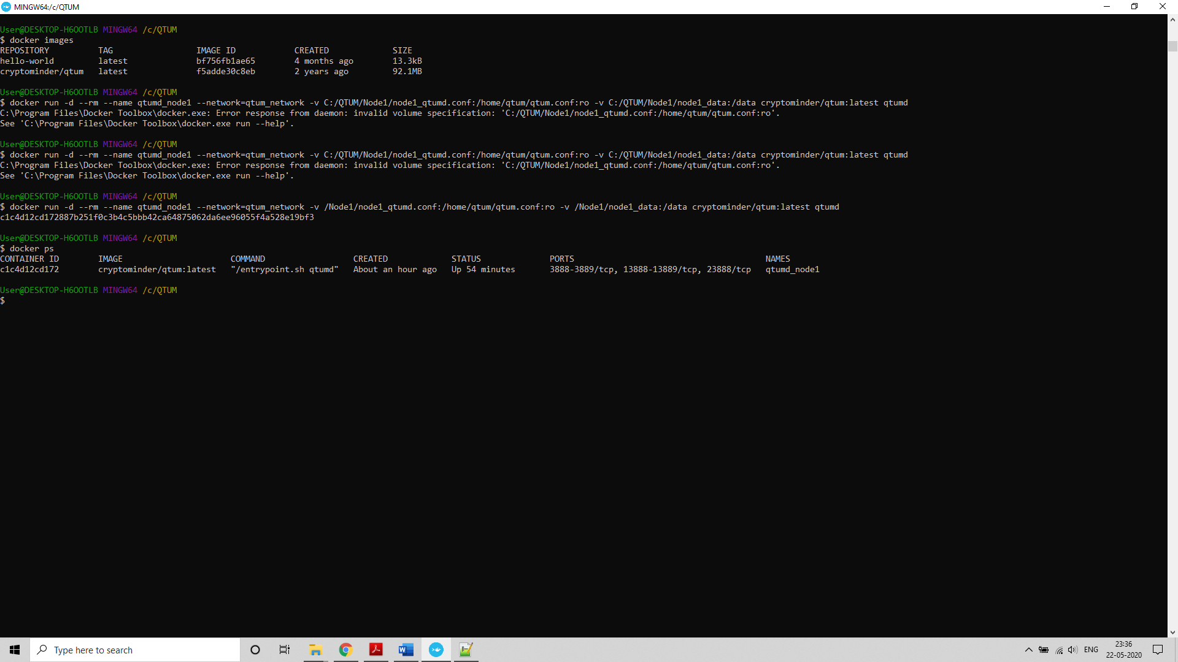

**Node 2**

docker run -d --rm --name qtumd_node2 --network=qtum_network -v C:/QTUM/Node2/node2_qtumd.conf:/home/qtum/qtum.conf:ro -v C:/QTUM/Node2/node2_data:/data cryptominder/qtum:latest qtumd

**Run node 3**

docker run -d --rm --name qtumd_node3 --network=qtum_network -v C:/QTUM/Node3/node3_qtumd.conf:/home/qtum/qtum.conf:ro -v C:/QTUM/Node3/node3_data:/data cryptominder/qtum:latest qtumd

docker run -d --rm --name qtumd_node3 --network=qtum_network -v {pwd}/Node3/node3_qtumd.conf:/home/qtum/qtum.conf:ro -v {pwd}/Node3/node3_data:/data cryptominder/qtum:latest qtumd

**Execute the nodes and enter the container**

*docker exec -it* qtumd_node1 *sh*

*docker exec -it* qtumd_node2 *sh*

*docker exec -it* qtumd_node3 *sh*

docker run -it --rm \

--name myapp \

-v `pwd`:/dapp \

-p 9899:9899 \

-p 9888:9888 \

-p 3889:3889 \

hayeah/qtumportal

**QTUM get info**

Node 1

docker run -i --network container:qtumd_node1 -v /Node1/node1_qtumd.conf:/home/qtum/qtum.conf:ro -v /Node1/node1_data:/data cryptominder/qtum:latest qtum-cli getinfo

Node 2

docker run -i --network container:qtumd_node2 -v /Node2/node2_qtumd.conf:/home/qtum/qtum.conf:ro -v /Node2/node2_data:/data cryptominder/qtum:latest qtum-cli getinfo

**Generate blocks**

Node 1

docker run -i --network container:qtumd_node1 -v /Node1/node1_qtumd.conf:/home/qtum/qtum.conf:ro -v /Node1/node1_data:/data cryptominder/qtum:latest qtum-cli generate 10

**List contracts on the node**

docker run -i --network container:qtumd_node1 -v /Node1/node1_qtumd.conf:/home/qtum/qtum.conf:ro -v /Node1/node1_data:/data cryptominder/qtum:latest qtum-cli listcontracts

Delete exited Docker containers

docker ps -a | grep Exit | cut -d ' ' -f 1 | xargs docker rm

Option 2:

**Start qtumd in regtest mode:**

docker run -it --rm --name node3g -v /dapp:/dapp -p 9899:9899 -p 9888:9888 -p 3889:3889 hayeah/qtumportal

Execute the dapp:

*docker exec -it node3g sh*

**Generated 600 blocks**

*/dapp # qcli generate 600*

*/dapp # qcli getnewaddress*

qdoZaVRvLRehGPDg2nGV9y8gwcZFgJcsoP

**Sending 10 QTUM to address**

qcli sendtoaddress qdoZaVRvLRehGPDg2nGV9y8gwcZFgJcsoP 10

19db7d4f1b406d952cc0d90ac7ee4c01af283b3afd698fe75f3dc41ea59bf4f0

**Set sender address - to configure the deployment tool solar to use this particular address as the owner**

export QTUM_SENDER=qdoZaVRvLRehGPDg2nGV9y8gwcZFgJcsoP

solar deploy MyContract.sol

docker run -d --rm --name qtum_node -p 3889:3889 -v //c/QTUM/dapp/data/qtum.conf:/root/.qtum/qtum.conf -v //c/QTUM/dapp/data/qtum-data:/root/.qtum/ qtum/qtum qtumd

QTUM dapp creation

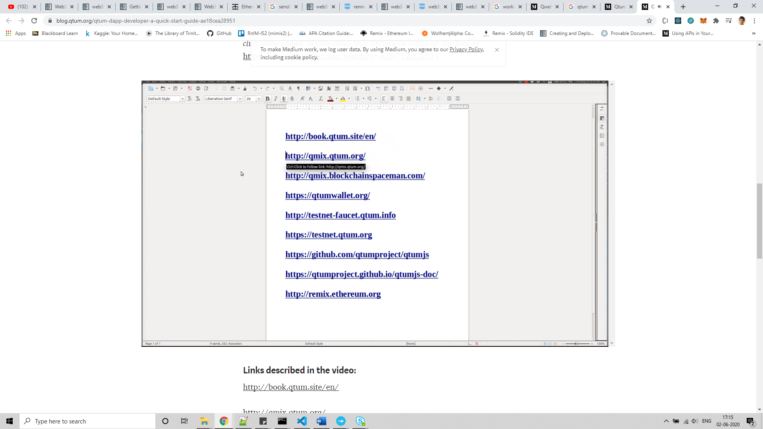

<https://blog.qtum.org/qtum-dapp-developer-a-quick-start-guide-ae18cea28951>

ERC 20 token with QTUM

Solr, qcli

<https://github.com/onggunhao/qtum-intro/blob/master/README.md>

qmix.qtum.org